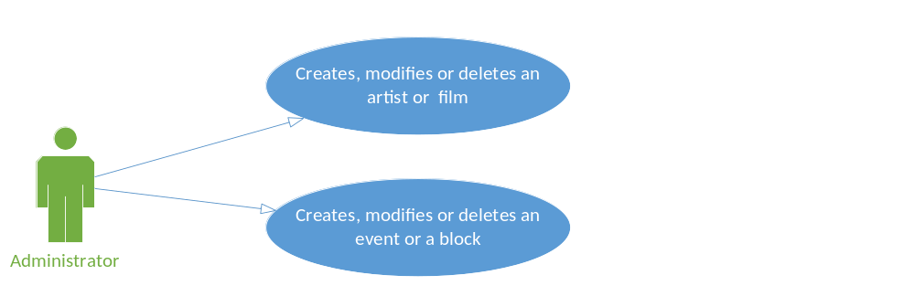Outline Administrator Use Case

Above diagram indicates there is two use case. What are the actual names of use case? Those are not how use cases are named?

I see outline for only one use case, where is the outline for another use case?
For which use case is below outline? Below outline is very generic does not make any relevant connection to either of the use cases?

Brief Description:
An administrator creates, modifies or deletes an event related entity

Basic Flow:
- Administrator logs in
- Administrator creates new data
- End use case

Alternative Flows:
A1 Administrator is presented with existing data in the system
A2 Administrator chooses to “Edit” data
A3 Administrator chooses “Details”
A4 Administrator chooses “Delete”

Sub Flow:
S1 Administrator logs in

Pre-conditions:
The system is a web-based application therefore internet access must be available and Administrator must navigate and login to system prior to executing Use Case

Scenarios:
Success scenarios
Administrator adds all relevant data in proper format and system accepts – basic flow
Administrator uses auto complete functionality and system accepts – A1 alternate flow, basic flow
Administrator uses “Edit” functionality and system accepts – A2 alternate flow, basic flow
Administrator uses “Details” functionality to review data – A3 alternate flow, basic flow
Administrator uses “Delete” functionality to delete data and system accepts – A4 alternate flow, basic flow

Failure scenarios
Administrator does not enter all required data or data is not in proper format, system displays error message and highlights any field with improperly formatted data

